- Using a ¼” Nut Driver Remove the Genysis Control from the Electric Box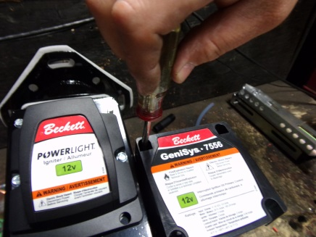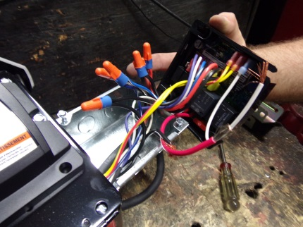
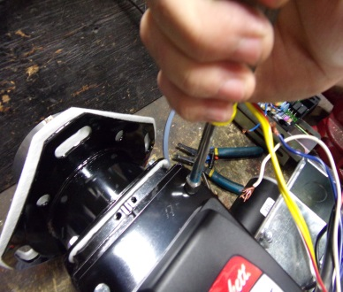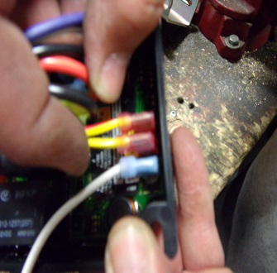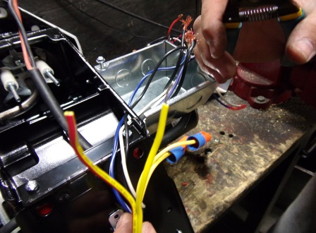

- Open the Igniter with a ¼” Nut Driver, find the two yellow wires on the Genysis, cut and strip them and then attach these to the two yellow wires in the igniter electric box using the wire nuts.
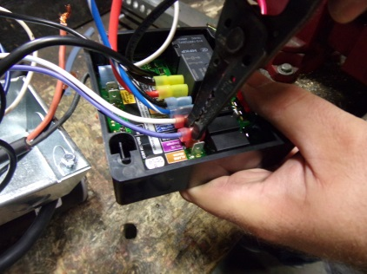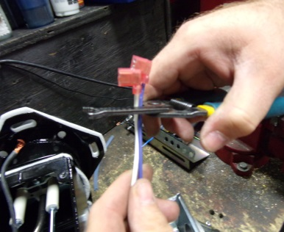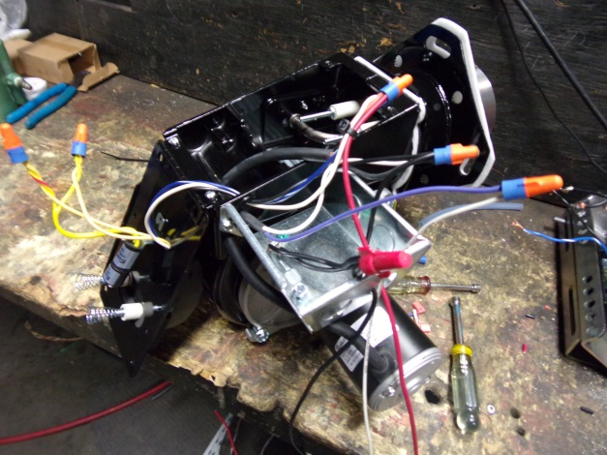

- Locate One Purple Wire and One White Wire on the Genysis,(Wires from Fuel Coil) cut, strip and connect the Purple wire to the incoming white wire.
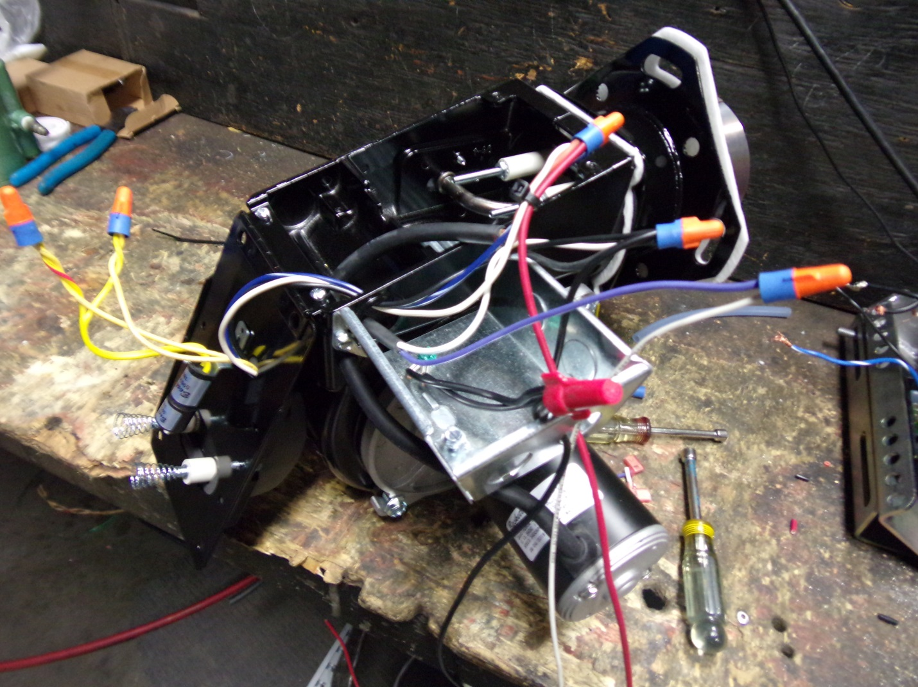
- Attach the white fuel coil ground wire with the incoming Black (From Battery) along with the black ground from the motor, Igniter and electric box. A short jumper wire may be needed

- Attach and wire nut the Remaining White from the Igniter, Blue/White Striped From Igniter, Orange from Motor to the Incoming Red Wire.

- You will need to acquire a 4x4 electric box cover from any hardware store. Insure all wire nuts are tight. Tuck the wires in the electric box and cover. Close the Igniter insuring that no wires are pinched and tighten screws to secure.

- This complete the conversion.

